**Change in Quantity Supplied**

| What causes a change in quantity supplied? | Caused by an increase or decrease in price |
| --- | --- |
| How do you show this on supply graph? | Cause of movement along the supply line, upward slope |

**Change in Supply**

| What do you do on a supply graph to show an increase in supply? | We Have to shift the line to the right if there is an increase in supply and shift the line |
| --- | --- |

| What do you do on a supply graph to show a decrease in supply? | Shift the demand line to the left if there is a decrease |
| --- | --- |

*Insert a photo of your change in supply graph here*

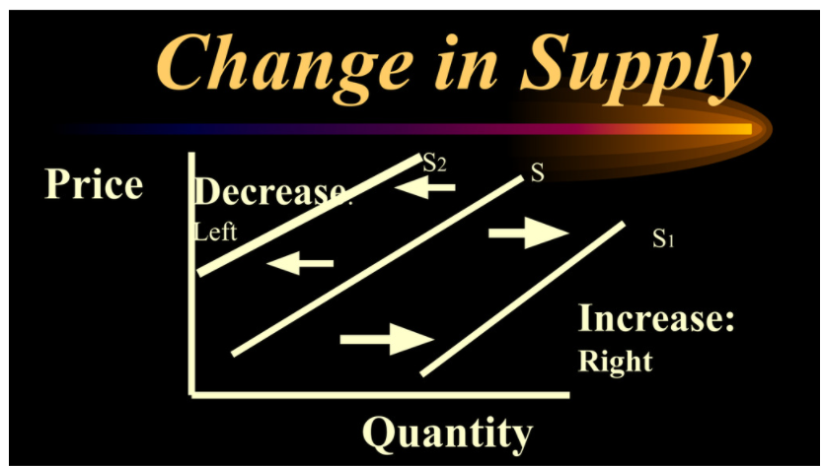

**Technological Advances**

| Provide a photo of an advancement in technology increased the production of a product. Explain this example. You’ll need to bring up the technological advancement and the good or service that it helps to produce | Elon Musk: SpaceX's future Starship to be built in Florida | wtsp.com  This is an advancement in technology, because it provides us transportation off the planet just in case if there is a apocalypse |
| --- | --- |

**Change in Input (Factor) prices**

**If the price of a factor of production goes up,producers may not be able to afford to produce as musch as they used to**

| Provide a photo of a resource that if it changes in price, it may change the production of a good or service. Explain this example. You’ll need to bring up the resource and the good or service that it helps to produce | corn | History, Cultivation, Uses, & Description | Britannica  If corn gets more expensive, the production of popcorn will decrease.  If corn gets cheaper, the production will increase. |
| --- | --- |

**Change in the # of Producers**

Businesses entering and leaving the market changes the market supply for G & S

| Insert photos of a type of business that you don’t see as much anymore because they have left the market | Top 10 Pharmaceutical Companies in the World Pharmapproach.com  There are more medical stores/restaurants/companies so the market supply of drugs, and vaccinations have increased.  There are less dvd stores/restaurants/companies so the market supply of dvds have decreased. |
| --- | --- |

| Insert photos of a type of business that you see more of these days |  |
| --- | --- |

**Change in Producer Expectations For Future Prices**

| Insert a photo of something that businesses begin producing far before they’re able to sell it for a higher price |  |
| --- | --- |

**Change in Business Taxes**

| Explain why a change in business taxes may impact production (supply) | Increases in tax rates placed upon businesses often prompts some businesses to lower their production |
| --- | --- |

**Change in Subsidies**

| What is a subsidy? | The opposite of a tax, it is financial assistance the government provide to people and businesses |
| --- | --- |
| Explain why a subsidy could impact production (supply) | Encourages more production.When government subsidies are implemented to the supplier, an **industry is able to allow its producers to produce more goods and services**. This increases the overall supply of that good or service, which increases the quantity demanded of that good or service and lowers the overall price of the good or service. |

**Change in Price of Substitute Goods**

| Insert a photo of two things that can substitute for each other | Jeep Brings Back Wrangler Freedom Edition as Armed Forces TributeFastest Pickup Trucks for 2020 - 2021 (Best 0-60) | Motor1.com |
| --- | --- |
| Explain how being able to sell one of those things for a higher price might discourage the production of its substitute | If the pirus increases the quantity supplied will increase is the law of supply.  To increase the QS of the prius, toyota may have to decrease the supply(production) of the sequoia |

**Change in Price of Complementary Goods**

| Insert a photo of two things that complement each other | Buy iPhone 11 - AppleBuy AirPods Pro - Apple |
| --- | --- |
| Explain how being able to sell one of those things for a higher price will encourage the production of its complement | If apple believes that it can sell their newest iphone for a higher price, they will increase the quantity supplied. This is the law of supply  Airpods  This may motivate them to increase the production(supply) of Airpods for the new iPhones  If a business believes that it can charge a higher price for a G or S, it will shift factors of production so it can produce more of that good & also that good’s component |